Case 6-Afr-Burkina Faso-Mossi-Biga-Statue-Aniconic-Wood-1st half 20th c

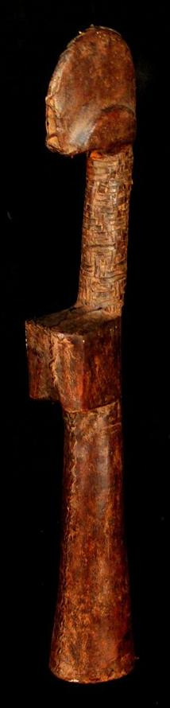

Case No.: 6

Accession Number:

Formal Label: Afr-Burkina Faso-Mossi-Biga-Statue-Aniconic-Wood-1st half 20th c

**Display Description:**

Biga means “child” and is a girl’s educational device among the Mossi of Burkina Faso to prepare the girls for their future roles as mothers. The primary rôle of Biga is educational. However, when an adult woman is newly married the rôle becomes one of promoting fertility as she departs her father’s domicile and brings her Biga to her newly married husband.

Biga were carved from wood and could be covered in pieces of leather as in this example. The arms and legs are not represented but the doll still bears breasts to symbolize motherhood. The shape of the head reflects the tribal origin, with hair shaped in a crest and with facial scars. Over the years, the girl will carry and hold the doll and anoint it with butter and oils. While some figurines are eventually discarded, others are passed down or inherited from a family member. In this case they represent the female family lineage.

The aniconic aspect of these Biga statuettes is also important in this respect, because they represent not an individual's appearance but the abstract identity of the familial lineage of the women of the local group. As such they are carriers of familial maternal identity. This is one aspect of how in a preliterate society that historical memory can be passed down the generations.

LC Classification: NK1087

Date or Time Horizon: First half 20th century

Geographical Area:

Map:

GPS Coordinates:

Cultural Affiliation:

Medium: wood

**Dimensions**: H 13.77 inches  
**Weight:** 0.599 lbs

**Provenance**:

**Condition:**

**Discussion:**

**References:**